DAT602 Project
  - - Dylan Fry -
Project Link: https://github.com/0rbios/DAT602-Project

- Milestone 1 -

1 Game Summary
In this game, players take control of a robotic suit. They travel around a tile-based map, picking up upgrades which they can load into their suit to increase their power and score. Players can also battle each other to gain score and defend their high score.

2 Players
2.1 Account Types
2.1.1 Overview
There are two account types:
- Administrator
- Player

2.1.2 Administrator
Administrator accounts have a more back-end view of the game.

2.1.3 Administrative Abilities
Administrator accounts have the following abilities:
- Lock/Unlock accounts
- Delete accounts
- Change inactive account types (Admin/Player)
- Kick active accounts from the game
- Create new accounts
- Change the information of an existing account

2.1.4 Player
Player accounts have a more front-end view of the game.

1.2.5 Player Abilities
Users with player accounts have the ability to delete their own account.

2.1.6 Login
Each player has a username and password.

When a player attempts to log in, if the username they have entered is not in the database, the user will be asked if they want to make a new account, if they say yes then a new account will be created with the entered username and password.

When a new account is created, the player will automatically be joined into the game.

If the username is in the database but the entered password does not match, the player will be told that the login failed and asked to try again.

If the player inputs a wrong password 5 times, the username they were attempting to log in to will be locked and they will be presented with an administrator email to contact. Locked accounts cannot be logged in to by anyone until an administrator unlocks the account.

If the username and password are correct, the player will be successfully logged in and able to play.

3 Stats
3.1 Overview
There are 4 player statistics:
- Strength
- Speed
- Health
- Energy

Each player also has a statistic total which is determined by the sum of the 4 statistics values. (E.g. 2 Strength + 2 Speed + 1 Health + 1 Energy = 6 Stat Total)

3.2 Strength
Strength is the statistic used to determine damage output. Ability base damage is multiplied based on it.

3.3 Speed
Speed is the stat used to determine the frequency / movement time for a player to go to different tiles.

3.4 Health
Health is the player stat that affects the maximum health value a player can have.

3.5 Energy
Energy is the player stat that affects the speed which players regenerate energy at.

4 Classes
4.1 Overview
There are 4 classes:
- Gorilla
- Cheetah
- Eagle
- Tiger

Each class has an increase (+1) to 2 statistics and a decrease (-1) to 2 statistics.

Each class also has a unique starting ability.

4.2 Gorilla
The gorilla class begins with increased strength and health but decreased speed and energy.

The gorilla class starts with the piston wreck ability.

4.3 Cheetah
The cheetah class begins with increased speed and energy but decreased strength and health.

The cheetah class starts with the hyper-speed kick ability.

4.4 Eagle
The eagle class begins with increased speed and health but decreased strength and energy.

The eagle class starts with the wing swipe ability.

4.5 Tiger
The tiger class begins with increased strength and energy but decreased speed and health.

The tiger class starts with the claw strike ability.

5 Abilities
5.1 Overview
Abilities are actions which energy can be expended to use.

Any class can use any ability.

Each ability has the following details:
- Name
- Description
- Value
- Energy cost
- Use time

Abilities which can be used in combat also have a damage output.

The value of each ability changes the player's score. When an item is removed from the player's inventory, their score will decrease. When an item is added, it will increase.

6.1 Energy
Every ability uses some amount of energy. Energy regenerates at a speed based on the player's energy stat.

6.2 Using Abilities
Players can use abilities by clicking on an available ability icon.

6.3 Ability Availability
Ability availability is based on the following criteria:
- Ability use case
- Energy cost vs energy amount
- Recently used abilities

6.4 Ability Use Case
If an ability can only be used in combat, but the player is not engaged in combat, then the ability will not be available.

6.5 Energy Cost VS Energy Amount
If the amount of energy which an ability needs is greater than the player's current energy amount, the ability won't be available.

6.6 Recently Used Abilities
For a short period (~0.5 Seconds) after an ability is used, it will be unavailable. This is more to avoid ability spam.

7 Score
7.1 Overview
Each player has a score which increases as they play.

When a player is defeated, their score resets to 0.

Each player also has a high score which is displayed in the leaderboard.

8 Combat
8.1 Overview
When one player is adjacent to another player, they can click on the other player to engage in combat.

Combat can be exited by clicking on another tile to move away.

When in combat, players use their combat abilities to damage each other and reduce their opponent’s health.

Winning in combat increases the winning player's score based on the score of the losing player and their statistic point total.

When a player is defeated, they lose all of their upgrades and are sent back to the home tile with their starting loadout.

9 Map
9.1 Tiles
9.1.1 Overview
The map is made up of tiles. Each tile can contain 4 items and (with one exception) 1 player.

9.1.2 Home Tile
All players initially start on the home tile; this is the only tile which is able to hold multiple players.

9.1.3 Rejoining
When a player leaves and rejoins the game, they will be placed back on the tile which they were on when they left the game. If this is not possible, then they will be asked to select a new valid tile to spawn on.

9.2 Movement
9.2.1 Overview
Players move around the map by clicking on adjacent tiles. If a tile is empty (no other player on it) then the player is able to move to it, otherwise they will engage in combat with the other player.

The amount of time which a player must wait to move is determined by their speed stat, with 0 wait time being the absolute minimum.

Players can still enter combat and access the tiles items while they are waiting to be able to move again.

If two players click on the same empty tile, the first player to click the tile will be the one who moves, the other player will not move.

10 Pickups
10.1 Overview
Players pick up items from tiles. Every item grants the user either an ability or statistic change.

Players can hold up to 4 ability items and 4 stat items.

To pick up or drop an item, the player clicks on the item and then where what valid inventory slot they want to move it to (this can either be on the player or the tile).

10.2 Glitch Abilities
10.2.1 Overview
Glitch abilities are pickups which randomly move around the map to empty tiles every second. If a player moves to a tile with a glitch ability, it will temporarily stop moving.

As soon as the player leaves the tile, the glitch ability will move.

11 Chat
11.1 Overview
Players are able to send messages through the in-game chat.

Each message has a username, send datetime, and the message text itself.

12 Ability Library
The following is a list of each ability and its details:

Iron Core
Type: Upgrade
Description:
+1 Health | -1 Speed

A forged iron core to increase the durability of a suit.

Value: 5

Steel Core
Type: Upgrade
Description:
+3 Health | -2 Speed

A forged steel core to better increase the durability of a suit.

Value: 10

Platinum Core
Type: Upgrade
Description:
+5 Health | -3 Speed

A forged platinum core to greatly increase the durability of a suit.

Value: 15

Loose Spring
Type: Upgrade
Description:
+1 Health | -1 Strength

A stretched spring, not very springy but bends easily.

Value: 5

Tight Spring
Type: Upgrade
Description:
+1 Strength | +1 Energy | -2 Health

A firm spring, plenty of potential energy but not very flexible.

Value: 10

Overtightened Spring
Type: Upgrade
Description:
+3 Energy | +2 Strength | -4 Health

A spring that seems to have somehow been twisted past its usual breaking point. Extremely high potential energy but will not hold up well to stress.

Value: 15

Ping
Type: Ability (Utility)
Description:
Scan the surrounding area for signals. (Tile inventory will include surrounding tiles as well until player moves)

Value: 12
Energy Cost: 5

Piston Wreck
Type: Ability (Combat) - Gorilla Starting Ability
Description:
Utilise the added force of the pistons in a suit to increase the power of a punch.

Value: 6
Energy Cost: 1
Base Damage: 2

Wing Swipe
Type: Ability (Combat) - Eagle Starting Ability
Description:
Swipe a suit's wing (or arm) with the added assistance of its propulsion jet.

Value: 6
Energy Cost: 1
Base Damage: 2

Claw Strike
Type: Ability (Combat) - Tiger Starting Ability
Description:
Use a suit’s claws (or fist) to damage a target.

Value: 6
Energy Cost: 1
Base Damage: 2

Hyper-Speed Kick
Type: Ability (Combat) - Cheetah Starting Ability
Description:
Utilise the fast bearings in a suit’s legs to kick a target at increased speed.

Value: 6
Energy Cost: 1
Base Damage: 2

Jump-Kick
Type: Ability (Combat)
Description:
Jump into the air and kick a target.

Value: 10
Energy Cost: 4
Base Damage: 5

Laser
Type: Ability (Combat)
Description:
Fire a high-powered laser at a target.

Value: 16
Energy Cost: 6
Base Damage: 10

Teleport
Type: Glitch Ability (Utility)
Description:
Phase-shift a suit and its occupant to a different place. (Move to any empty tile on the map)

Value: 30
Energy Cost: 10

Speed Shift
Type: Glitch Upgrade
Description:
+5 Speed

A mechanical switch which makes it substantially faster to shift up (and down) speed levels of a suit.

Value: 25

Iron Plating
Type: Upgrade
Description:
+1 Health | -1 Energy

Forged iron plating for the exterior of a suit. Seems to interfere with energy conduction.

Value: 5

Steel Plating
Type: Upgrade
Description:
+3 Health | -2 Energy

Forged steel plating for the exterior of a suit. Seems to interfere with energy conduction.

Value: 10

Platinum Plating
Type: Upgrade
Description:
+5 Health | -3 Energy

Forged platinum plating for the exterior of a suit. Seems to interfere with energy conduction.

Value: 20

Overcharge
Type: Glitch Upgrade
Description:
+5 Energy

Send an excess amount of energy around the suit, disregarding component damage.

Value: 28

Cell
Type: Upgrade
Description:
+1 Energy | -1 Strength

An energy cell to store energy for later use. Seems to bounce off of surfaces easily.

Value: 3

Double-Cell
Type: Upgrade
Description:
+4 Energy | -2 Strength

Two energy cells to store more energy for later use. Seem to bounce off of surfaces easily.

Value: 6

Triple-Cell
Type: Upgrade
Description:
+6 Energy | -3 Strength

Three energy cells to store a lot more energy for later use. Seem to bounce off of surfaces easily.

Value: 12

Quad-Cell
Type: Upgrade
Description:
+8 Energy | -5 Strength

Four energy cells to store an overwhelming amount of energy for later use. Seem to bounce off of surfaces easily. One might question the diminishing returns of so many cells.

Value: 24

11 Storyboards
- Login Screen
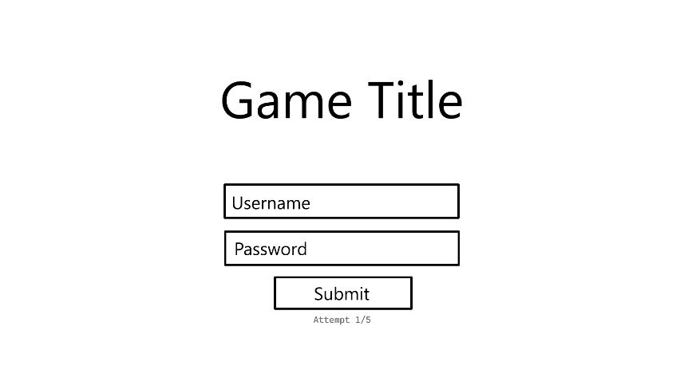  4  3  2  1 | - Text Input – A text box for the player to write their username. This input is compared to the usernames in the database when the user tries to log in.  - Text Input – A text box for the player to write their password. This input is compared to the password in the database when the user tries to log in.  - Button – Attempts to log in with the given information. If the username and password are correct sends the player to the room select menu (Storyboard 4) and sets the accounts attempts value to 0 in the database, if the username is not in the database (Storyboard 2), or if the password is not associated with the given username in the database, the player will be told that the username or password was wrong and given another attempt up to 5 times. After the fifth failure, the account with the given username will have its locked value set to true in the database and the player will be shown the account lockout message. (Storyboard 3)  - Text – Displays the players sign in attempt count. Gets this information from the account login attempts value in the database. Gets the value associated with the given username so will change when the username is changed.
| |  | |
- Account Registration Popup
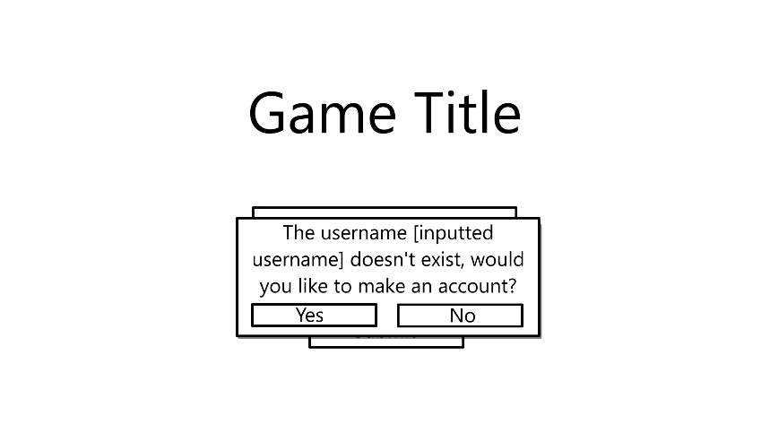  2  1 | - Button – Creates a new account with the given username and email in the database. Automatically logs the player in and sends them to the room select menu. (Storyboard 4)  - Button – Takes the player back to the login screen. (Storyboard 1)
| |  | |
- Locked Account Message
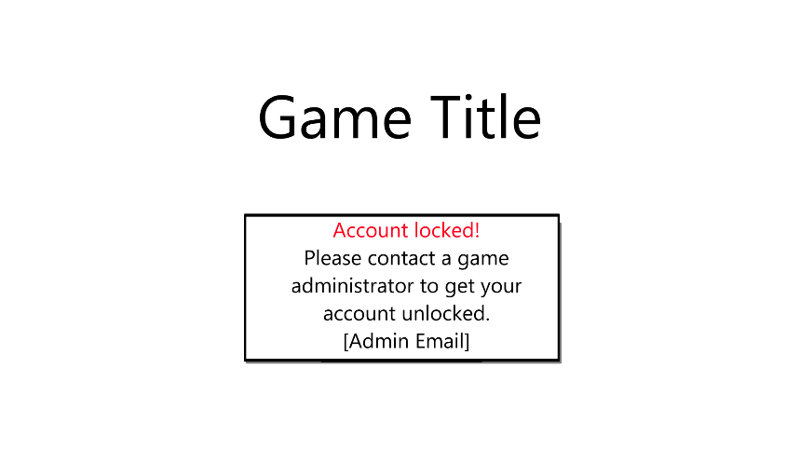 | This menu will completely lock the player out of logging in until they restart the game.
| | |
- Room Selection Screen
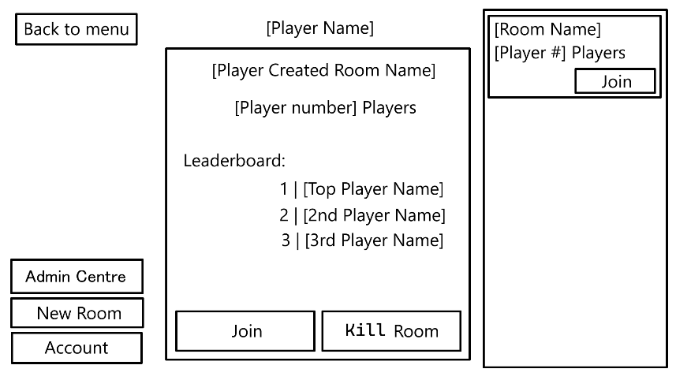  7e  7d  7c  7b  7a  7  6  5c  5b  5a  5  4  3  2  1 | - Button – Returns the player to the login screen. (Storyboard 1)  - Button – Only visible to accounts in the database with the administrator value set to true. Takes the player to the administrator menu. (Storyboard 6)  - Button - Tries to initiate the room creation process. If the player doesn’t already have a room with their username attached in the database(Storyboard 8), if the player has already created a room. (Storyboard 9)  - Button – Opens the account options menu. (Storyboard 5)  - List – A scrollable menu of all available rooms pulled from the database.  5a. Text – The name of the room.  5b. Text – How many players are currently in the room.  5c. Button – Joins the player to the room. (Storyboard 18)  - Text – The player’s username.  - Menu – Details of the player’s currently created room. Blank if there is no room.  7a. Text – The name of the current room.  7b. Text – The current number of players in the room.  7c. Button – Joins the player to the room. (Storyboard 18)  7d. Button – Opens the room deletion menu. (Storyboard 10)  7e. List – Displays the current players in first, second and third place, if applicable.
| |  | |
- Player Account Options
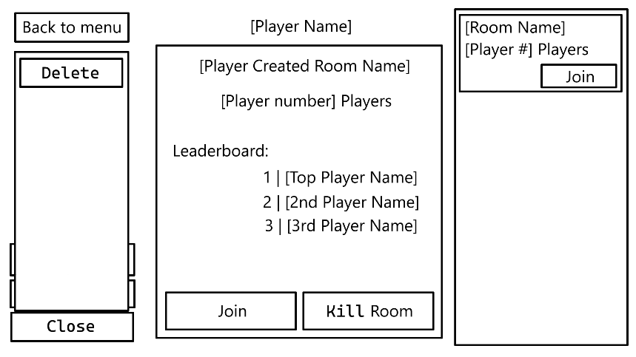  1 | - Button – Asks if user is sure. (Storyboard 14)
| | |
- Administrator Screen (Rooms)
3
2a
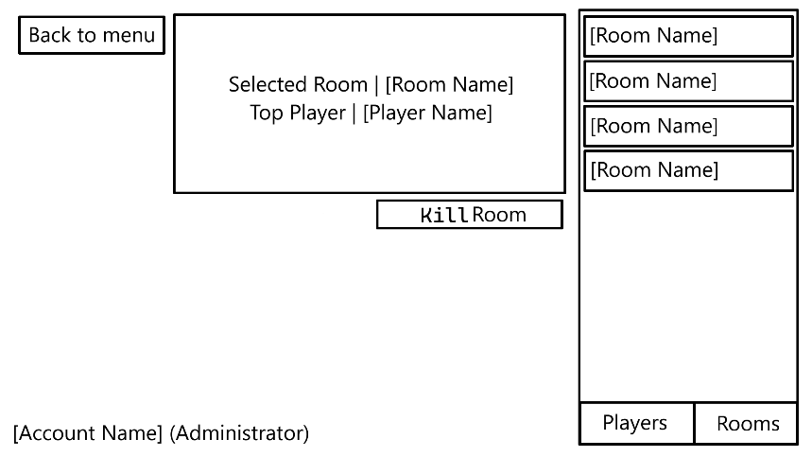  5  4  3b  3a  2c  2b  2  1 | - Button - Takes the player back to the room selection menu. (Storyboard 4)  - List – A list of all available rooms pulled from the database.  2a. Button – Selects the corresponding room.  2b. Button – Takes the player to the player menu. (Storyboard 7)  2c. Button – Greyed out because selected.  - Menu – Displays information about the currently selected room.  3a. Text – The name of the room.  3b. Text – The username of the player with the highest score in the currently selected room.  - Text – The player’s username.  - Button - Opens the room closure confirmation popup. (Storyboard 15)
| | |
- Administrator Screen (Players)
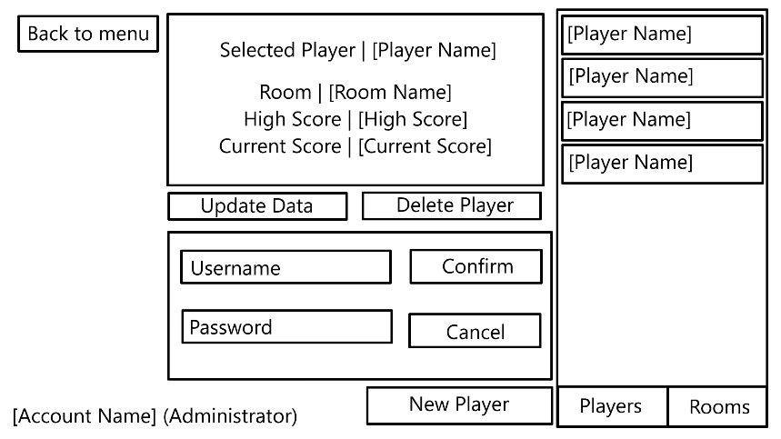  7e  7d  7c  7b  7a  7  6  4  3d  3c  3b  3a  3  2c  2b  2a  2  1 | - Button - Takes the player back to the room selection menu. (Storyboard 4)  - List – A list of all available players from the database.  2a. Button – Selects the corresponding player.  2b. Button – Greyed out because selected.  2c. Button – Takes the player to the room menu. (Storyboard 6)  - Menu – Displays information about the currently selected player.  3a. Text – The player’s username.  3b. Text – The player’s current room, if applicable.  3c. Text – The player’s current high score, if applicable.  3d. Text – The player’s current score, if applicable.  - Text – The player’s username.  - Button - Shows the player deletion confirmation popup. (Storyboard 17)  - Button - Takes the player to the player info edit menu. (Storyboard 16)  - Menu – Input methods to create a new player. Only visible when creating a new player.  7a. Text Input – A text input for the player to input a username.  7b. Button – Attempts to create a new player with the given information.  7c. Text Input – A text input for the player to input a password.  7d. Button – Cancels the player creation and closes the popup.  7e. Button – Opens the popup.
| | |
- Room Creation
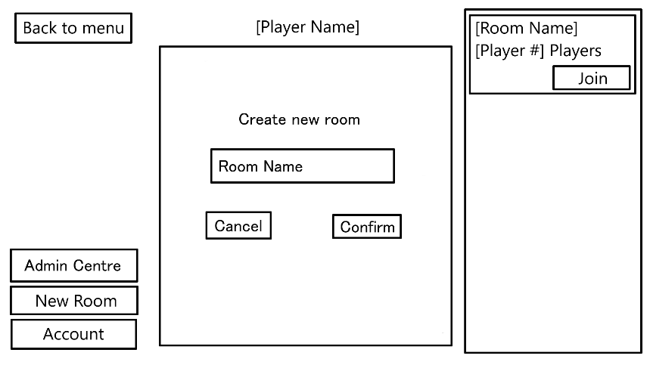  3  2  1 | - Button – Closes the menu. (Storyboard 4)  - Button –Tries to create the room and automatically connect the player.  - Text Input – A text box for the player to write a room name.
| | |
- Room Creation Existing Room Message
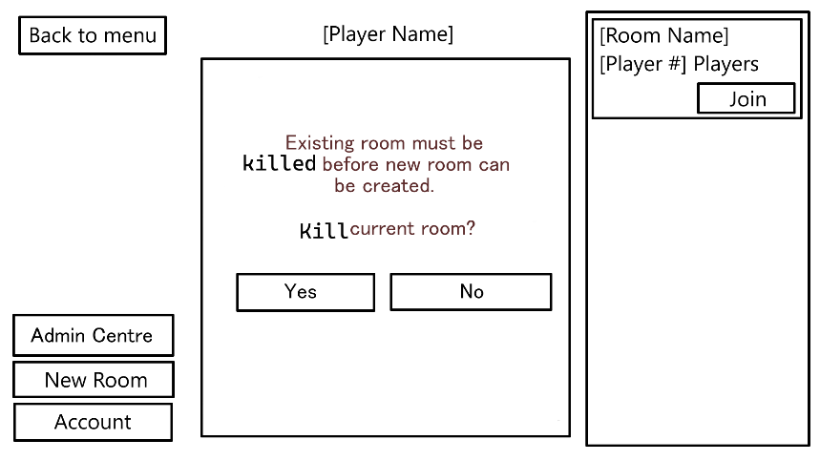  2  1 | - Button – Kills the room and goes to the room creation menu. (Storyboard 8)  - Button – Closes the menu. (Storyboard 4)
| | |
- Room Closing Message
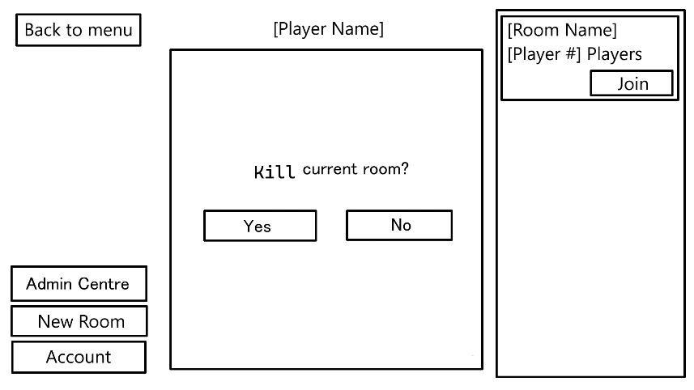  2  1 | - Button – Kills the room and goes back to the room select menu. (Storyboard 4)  - Button – Closes the menu. (Storyboard 4)
| | |
- Gameplay Screen
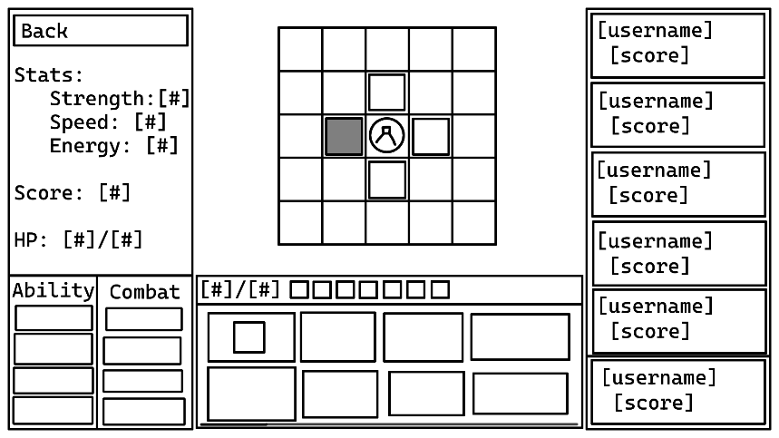  10  11  9  8  6  7  5a  5  4  3  1  2 | - Clickable Sprite – Displays a position which the player can move to, determined by the player’s latest position and the tiles around them. Creates a new entry in the player_tile table when clicked.  - Sprite – Displays a position which the player cannot move to.  - Sprite – Displays the player’s current position pulled from the player_tile table entry with the most recent timestamp.  - Button – Takes the player back to the room selection menu.  - List – Lists the current leaderboard from the players read from the player table where the room matches.  5a. Box – Shows the player’s current leaderboard position.  - Clickable Sprite – Tries to use the corresponding ability. Determined by the abilities in the player_ability table where the dropped value is NULL.  - Text – Displays the player’s current and maximum energy read from the database.  - Sprite – Displays an empty inventory slot.  - Clickable Sprite – Displays an occupied inventory slot. Clicking begins item movement process. (Storyboard 13)  - Text – Displays the player’s current statistics pulled from the player_statistic table.  - Scroll Bar – Scrolls the tile inventory if it exceeds the screen size.  The chat window will also open to the side with a multiline containing the message history and a text input for message input.
| | |
12. Glitch Item
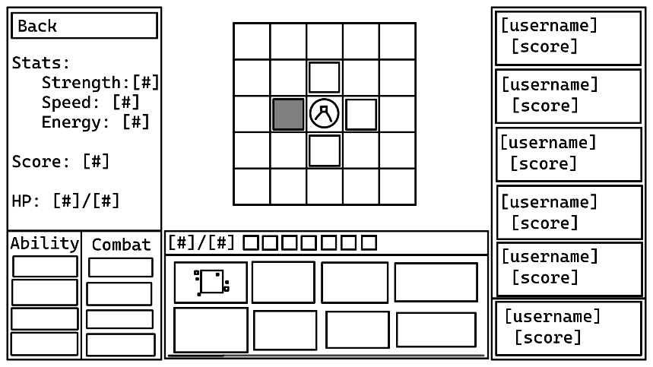  1 | - Clickable Sprite – Displays a glitch item. Glitch state is determined by the glitched value in the ability table. Relocates to a new random position on player movement.
| | |
- Item Movement
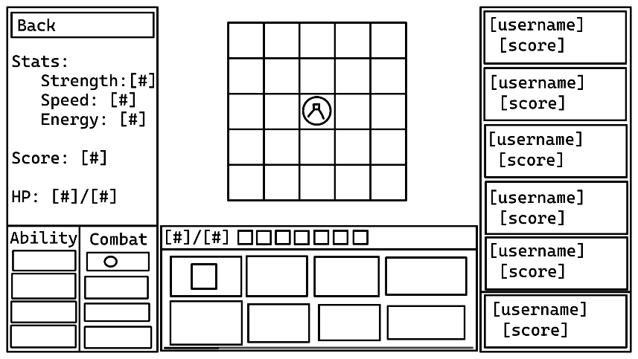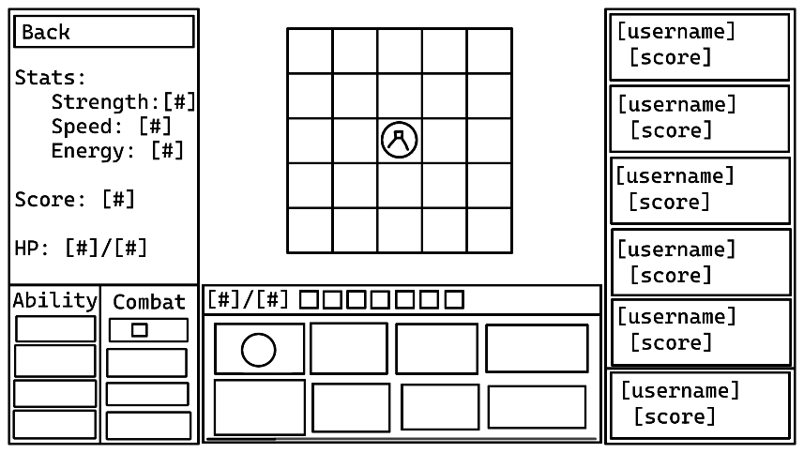  2  1 | - Clickable Sprite – Player selects the item to move.  - Clickable Sprite – Player selects item to swap with.  The items are the exchanged. If one of the slots is empty, then the empty slot will be filled and the filled slot will become empty.  The player’s score will update according to the items in their inventory at any given time.  When the items “swap”, the item in the player’s inventory will have its dropped value set to the current time and a new tile_ability entry will be created with the current time.
| | |
- Account Deletion Confirmation
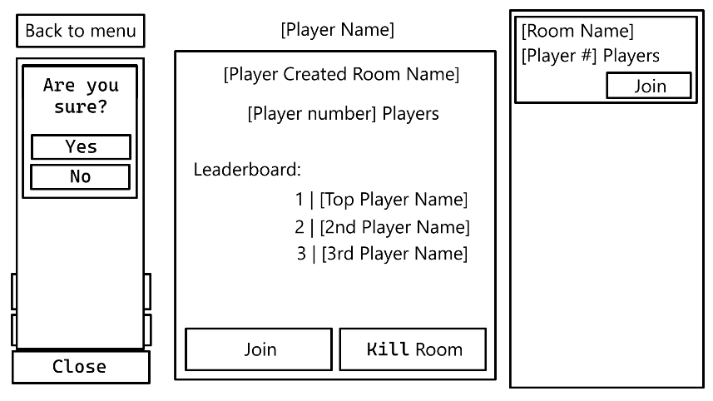  2  1 | - Button – Deletes the player’s account from the database and takes them back to the login screen. (Storyboard 1)  - Button – Closes the menu. (Storyboard 5)
| | |
- Room Closure Popup
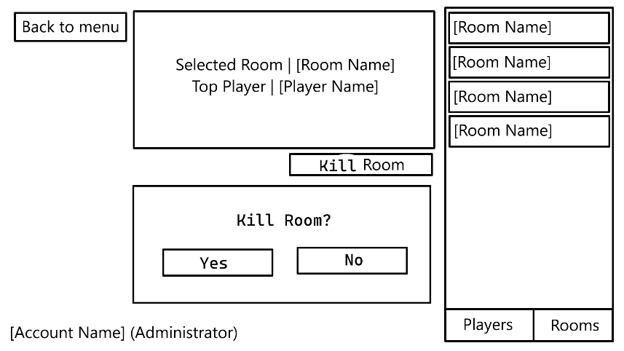  2  1 | - Button – Deletes the room and closes the menu. (Storyboard 6) Any players in the room will be sent to the room select screen. (Storyboard 4)  - Button – Closes the menu. (Storyboard 6)
| | |
- Player Info Edit Menu
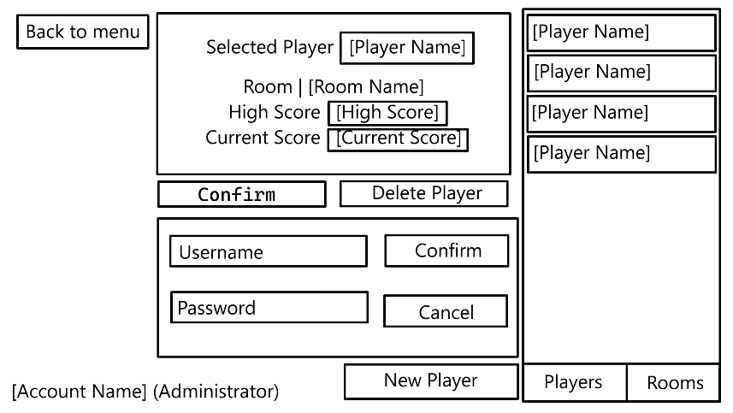  1  2  3  4 | - Textbox – A textbox to change the player’s username.  - Textbox – A textbox to change the player’s high score.  - Textbox – A textbox to change the player’s current score.  - Button – Changes the player’s details and moves back to non edit mode. (Storyboard 7)
| | |
- Player Deletion Confirmation Popup
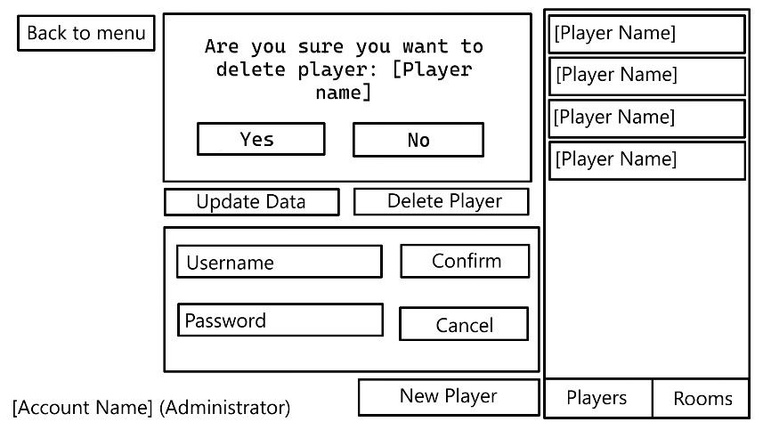  2  1 | - Button – Deletes the player and closes the popup. (Storyboard 7) Active players will be returned to the login screen. (Storyboard 1)  - Button – Closes the popup. (Storyboard 7)
| | |
- Room Join Menu
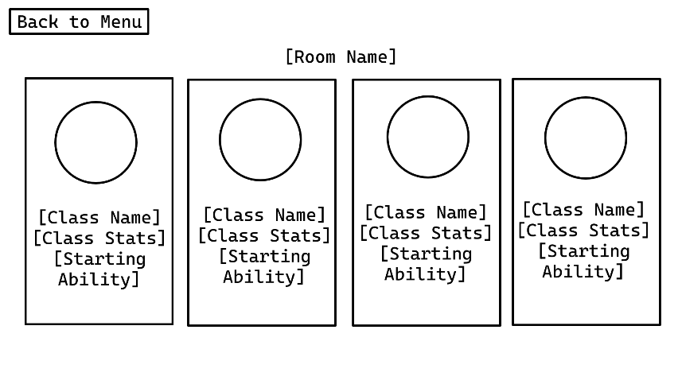  2d  2c  2b  2a  1  3  2 | - Button – Takes the player back to the room select menu. (Storyboard 4)  - Button – Selects the players class and sends them to the game board. (Storyboard 11)  2a. Sprite – The sprite for the player with this class.  2b. Text – The name of the class.  2c. Text – The stat changes from this class.  2d. Text – The starting ability of this class.  - Text – The name of the room.

12 ERD
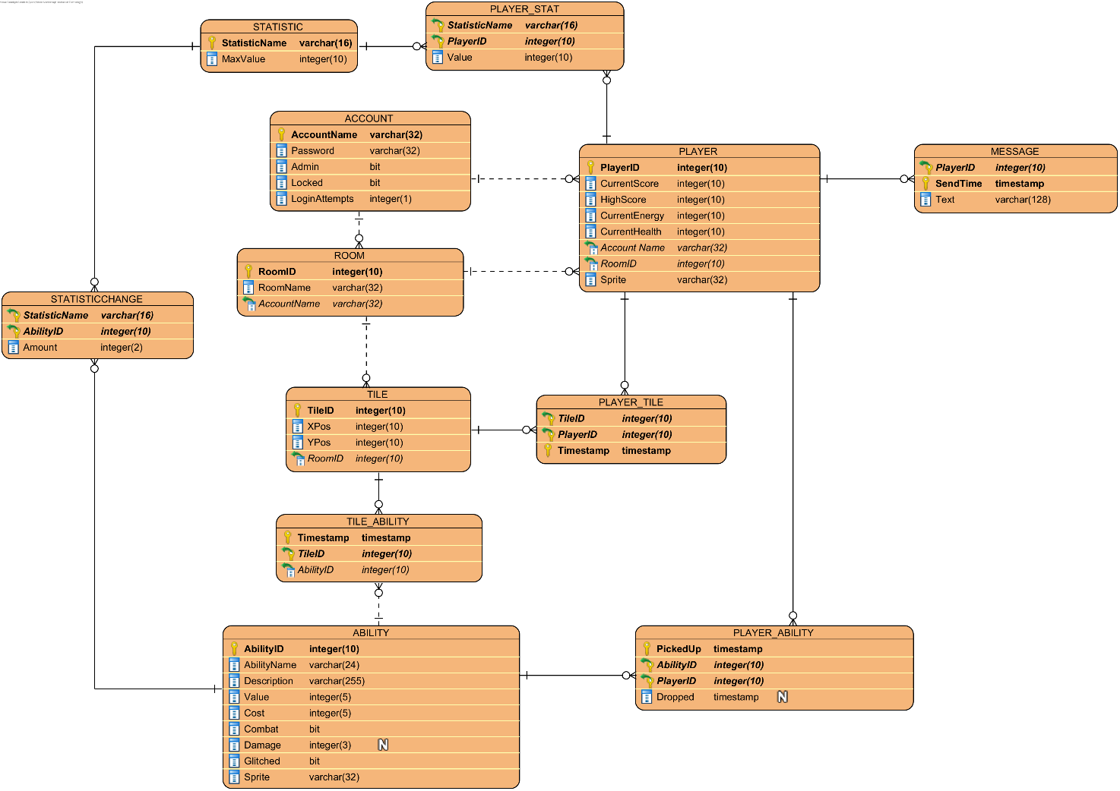

13 CRUD Table
Process > | Player Login | Incorrect Password | Player Lockout | Player Registration | Laying Out Tiles | Placing Item On Tile | Player Movement | Picking Up Item | Dropping Item | Winning Combat | Losing Combat | Glitch Item Movement | Kill A Room | Change Player Data | Delete An Account | Change Account Data | Player Join Room | Player Send Message | Create Room
Table \/
Account
AccountName (PK) | _R__ | _R__ | _R__ | CR__ | ____ | ____ | ____ | ____ | ____ | ____ | ____ | ____ | ____ | ____ | ___D | ____ | _R__ | ____ | ____
Password | _R__ | ____ | ____ | C___ | ____ | ____ | ____ | ____ | ____ | ____ | ____ | ____ | ____ | ____ | ___D | _RU_ | ____ | ____ | ____
Admin | _R__ | ____ | ____ | C___ | ____ | ____ | ____ | ____ | ____ | ____ | ____ | ____ | _R__ | ____ | ___D | __U_ | ____ | ____ | ____
Locked | _R__ | ____ | __U_ | C___ | ____ | ____ | ____ | ____ | ____ | ____ | ____ | ____ | ____ | ____ | ___D | __U_ | ____ | ____ | ____
LoginAttempts | __U_ | _RU_ | __U_ | C___ | ____ | ____ | ____ | ____ | ____ | ____ | ____ | ____ | ____ | ____ | ___D | ____ | ____ | ____ | ____
Player
PlayerID (PK) | ____ | ____ | ____ | ____ | ____ | ____ | _R__ | ____ | ____ | _R__ | ____ | ____ | ___D | ____ | ___D | ____ | C___ | _R__ | ____
CurrentScore | ____ | ____ | ____ | ____ | ____ | ____ | ____ | __U_ | __U_ | _RU_ | __U_ | ____ | ___D | __U_ | ___D | ____ | C___ | ____ | ____
HighScore | ____ | ____ | ____ | ____ | ____ | ____ | ____ | __U_ | ____ | __U_ | ____ | ____ | ___D | __U_ | ___D | ____ | C___ | ____ | ____
CurrentEnergy | ____ | ____ | ____ | ____ | ____ | ____ | ____ | ____ | ____ | ____ | ____ | ____ | ___D | __U_ | ___D | ____ | C___ | ____ | ____
CurrentHealth | ____ | ____ | ____ | ____ | ____ | ____ | ____ | ____ | ____ | ____ | ____ | ____ | ___D | __U_ | ___D | ____ | C___ | ____ | ____
AccountName (FK) | ____ | ____ | ____ | ____ | ____ | ____ | ____ | ____ | ____ | ____ | ____ | ____ | ___D | ____ | ___D | ____ | C___ | ____ | ____
RoomID (FK) | ____ | ____ | ____ | ____ | ____ | ____ | ____ | ____ | ____ | ____ | ____ | ____ | ___D | ____ | ___D | ____ | C___ | ____ | ____
Sprite | ____ | ____ | ____ | ____ | ____ | ____ | ____ | ____ | ____ | ____ | ____ | ____ | ___D | ____ | ___D | ____ | C___ | ____ | ____
Message
PlayerID (PK) (FK) | ____ | ____ | ____ | ____ | ____ | ____ | ____ | ____ | ____ | ____ | ____ | ____ | ___D | ____ | ___D | ____ | _R__ | C___ | ____
SendTime (PK) | ____ | ____ | ____ | ____ | ____ | ____ | ____ | ____ | ____ | ____ | ____ | ____ | ___D | ____ | ___D | ____ | _R__ | C___ | ____
Text | ____ | ____ | ____ | ____ | ____ | ____ | ____ | ____ | ____ | ____ | ____ | ____ | ___D | ____ | ___D | ____ | _R__ | C___ | ____
Room
RoomID (PK) | ____ | ____ | ____ | ____ | ____ | ____ | ____ | ____ | ____ | ____ | ____ | ____ | ___D | ____ | ___D | ____ | _R__ | ____ | C___
RoomName | ____ | ____ | ____ | ____ | ____ | ____ | ____ | ____ | ____ | ____ | ____ | ____ | ___D | ____ | ___D | ____ | _R__ | ____ | C___
AccountName (FK) | ____ | ____ | ____ | ____ | ____ | ____ | ____ | ____ | ____ | ____ | ____ | ____ | ___D | ____ | ___D | ____ | _R__ | ____ | C___
Player_Tile
TileID (PK) (FK) | ____ | ____ | ____ | ____ | ____ | ____ | C___ | ____ | ____ | ____ | C___ | _R__ | ___D | ____ | ___D | ____ | _R__ | ____ | ____
PlayerID (PK) (FK) | ____ | ____ | ____ | ____ | ____ | ____ | C___ | ____ | ____ | ____ | C___ | _R__ | ___D | ____ | ___D | ____ | _R__ | ____ | ____
Timestamp (PK) | ____ | ____ | ____ | ____ | ____ | ____ | C___ | ____ | ____ | ____ | C___ | _R__ | ___D | ____ | ___D | ____ | _R__ | ____ | ____
Tile
TileID (PK) | ____ | ____ | ____ | ____ | _R__ | _R__ | _R__ | ____ | _R__ | ____ | _R__ | _R__ | ___D | ____ | ___D | ____ | _R__ | ____ | C___
Xpos | ____ | ____ | ____ | ____ | _R__ | ____ | ____ | ____ | ____ | ____ | ____ | ____ | ___D | ____ | ___D | ____ | _R__ | ____ | C___
Ypos | ____ | ____ | ____ | ____ | _R__ | ____ | ____ | ____ | ____ | ____ | ____ | ____ | ___D | ____ | ___D | ____ | _R__ | ____ | C___
RoomId (FK) | ____ | ____ | ____ | ____ | _R__ | ____ | ____ | ____ | ____ | ____ | ____ | ____ | ___D | ____ | ___D | ____ | _R__ | ____ | C__
TILE_ABILITY
Timestamp (PK) | ____ | ____ | ____ | ____ | ____ | C___ | _R__ | _R__ | C___ | ____ | ____ | CR__ | ___D | ____ | ___D | ____ | _R__ | ____ | ____
TileID (PK) (FK) | ____ | ____ | ____ | ____ | ____ | C___ | _R__ | _R__ | C___ | ____ | ____ | CR__ | ___D | ____ | ___D | ____ | _R__ | ____ | ____
AbilityID (PK) (FK) | ____ | ____ | ____ | ____ | ____ | C___ | _R__ | _R__ | C___ | ____ | ____ | CR__ | ___D | ____ | ___D | ____ | _R__ | ____ | ____
Ability
AbilityID (PK) | ____ | ____ | ____ | ____ | ____ | CR__ | ____ | _R__ | _R__ | ____ | ____ | ____ | ____ | ____ | ____ | ____ | _R__ | ____ | ____
AbilityName | ____ | ____ | ____ | ____ | ____ | CR__ | ____ | _R__ | _R__ | ____ | ____ | ____ | ____ | ____ | ____ | ____ | _R__ | ____ | ____
Description | ____ | ____ | ____ | ____ | ____ | CR__ | ____ | _R__ | _R__ | ____ | ____ | ____ | ____ | ____ | ____ | ____ | _R__ | ____ | ____
Value | ____ | ____ | ____ | ____ | ____ | CR__ | ____ | _R__ | _R__ | ____ | ____ | ____ | ____ | ____ | ____ | ____ | _R__ | ____ | ____
Cost | ____ | ____ | ____ | ____ | ____ | CR__ | ____ | _R__ | _R__ | ____ | ____ | ____ | ____ | ____ | ____ | ____ | _R__ | ____ | ____
Combat | ____ | ____ | ____ | ____ | ____ | CR__ | ____ | _R__ | _R__ | ____ | ____ | ____ | ____ | ____ | ____ | ____ | _R__ | ____ | ____
Damage | ____ | ____ | ____ | ____ | ____ | CR__ | ____ | _R__ | _R__ | ____ | ____ | ____ | ____ | ____ | ____ | ____ | _R__ | ____ | ____
Glitched | ____ | ____ | ____ | ____ | ____ | CR__ | ____ | _R__ | _R__ | ____ | ____ | ____ | ____ | ____ | ____ | ____ | _R__ | ____ | ____
Sprite | ____ | ____ | ____ | ____ | ____ | CR__ | ____ | _R__ | _R__ | ____ | ____ | ____ | ____ | ____ | ____ | ____ | _R__ | ____ | ____
PLAYER_ABILITY
PickedUp (PK) | ____ | ____ | ____ | ____ | ____ | ____ | ____ | C___ | _R__ | ____ | _R__ | ____ | ___D | ____ | ___D | ____ | _R__ | ____ | ____
AbilityID (PK) (FK) | ____ | ____ | ____ | ____ | ____ | ____ | ____ | C___ | _R__ | _R__ | _R__ | ____ | ___D | ____ | ___D | ____ | _R__ | ____ | ____
PlayerID (PK) (FK) | ____ | ____ | ____ | ____ | ____ | ____ | ____ | C___ | _R__ | _R__ | _R__ | ____ | ___D | ____ | ___D | ____ | _R__ | ____ | ____
Dropped | ____ | ____ | ____ | ____ | ____ | ____ | ____ | C___ | __U_ | _R__ | __U_ | ____ | ___D | ____ | ___D | ____ | _R__ | ____ | ____
StatChange
AbilityID (PK) (FK) | ____ | ____ | ____ | ____ | ____ | C___ | ____ | _R__ | ____ | ____ | ____ | ____ | ____ | ____ | ____ | ____ | _R__ | ____ | ____
StatName (PK) (FK) | ____ | ____ | ____ | ____ | ____ | C___ | ____ | _R__ | ____ | ____ | ____ | ____ | ____ | ____ | ____ | ____ | _R__ | ____ | ____
Amount | ____ | ____ | ____ | ____ | ____ | C___ | ____ | _R__ | ____ | ____ | ____ | ____ | ____ | ____ | ____ | ____ | _R__ | ____ | ____
Stat
StatName (PK) | ____ | ____ | ____ | ____ | ____ | C___ | ____ | _R__ | ____ | ____ | ____ | ____ | ____ | ____ | ____ | ____ | _R__ | ____ | ____
MaxValue | ____ | ____ | ____ | ____ | ____ | C___ | ____ | _R__ | ____ | ____ | ____ | ____ | ____ | ____ | ____ | ____ | _R__ | ____ | ____
Player_Stat
StatName (PK) (FK) | ____ | ____ | ____ | ____ | ____ | ____ | _R__ | _R__ | _R__ | ____ | ____ | ____ | ___D | ____ | ___D | ____ | CR__ | ____ | ____
PlayerID (PK) (FK) | ____ | ____ | ____ | ____ | ____ | ____ | _R__ | _R__ | _R__ | ____ | ____ | ____ | ___D | ____ | ___D | ____ | CR__ | ____ | ____
Value | ____ | ____ | ____ | ____ | ____ | ____ | _R__ | __U_ | __U_ | ____ | ____ | ____ | ___D | ____ | ___D | ____ | CR__ | ____ | ____

14 Prototype
14.1 Login Screen
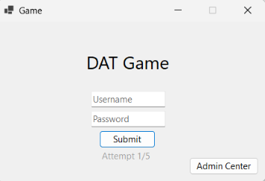
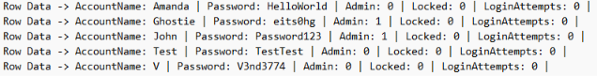

14.2 Gameplay Screen
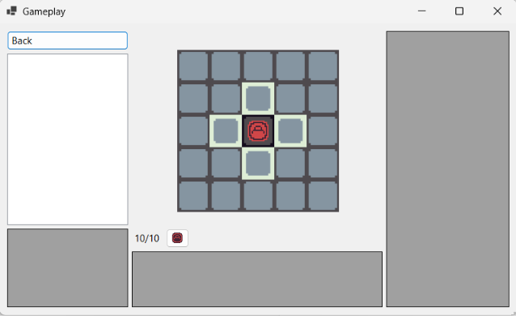
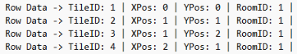

14.3 Administration Screen
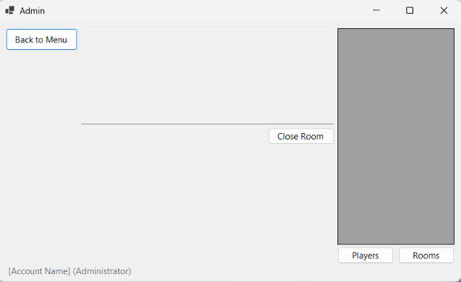

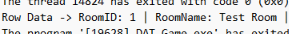

15 DDL
The DDL procedure uses one create table statement for each table in the database; it sets the primary key(s) and any foreign key(s) after defining each column. The procedure then inserts the test data in the same order which the tables were created in.

- Milestone 2 -

1 SQL Procedures
Generate_Database – Create all the tables for the database and insert the key data such as abiltites and an administrative account.
No Arguments

Create_Test_Data – Generates a set of test data by running the necessary procedures.
No Arguments

Player login, including lock out
Login – Attempts to log in to the account, increases the attempt count if failed, creates an account if one doesn’t exist or resets the attempt count if the login is successful and the account isn’t locked.
Username (VARCHAR32)
Password (VARCHAR32)

Player registration
Add new players
Create_Account – Attempt to create an account with the given username and password.
Username (VARCHAR32)
Password (VARCHAR32)

Create_Room – Creates a room, lays out its tiles and then places a calculated number of random abilities on random tiles.
Name of room (VARCHAR32)
Username of owner (VARCHAR32)

Laying out tiles on a game board
Layout_Tiles – Creates a square of tiles attached to a room based on a set size.
Room ID (INT)
Tile X Position (INT)
Tile Y Position (INT)

Placing an item on a tile
Place_Ability_On_Tile – Creates an ability instance for a given ability and places it on to a given tile.
Ability Name (VARCHAR24)
Tile to place on (INT)

Join_Room – Create a new player in the given room if one doesn’t exist, otherwise it checks if the player is able to be reactivated on their last position.
Name of account (VARCHAR32)
Room ID (INT)
Class of joining player (VARCHAR32)

Attach_Player_Stat – Links a statistic to a player.
ID of player (INT)
Name of statistic (VARCHAR32)

Get_Inventory – Get all of the abilities that are currently in a player’s inventory.
Account name (VARCHAR32)
Room to get player instance from (INT)

Player game player movement, i.e., moving a player to a “legal” tile
Move_Player – Attempts to move the player to a given tile.
Account name (VARCHAR32)
Room to get player instance from (INT)
X Position to move to (INT)
Y Position to move to (INT)
How far the player is allowed to move away from their current position in tiles (INT)
If the player is allowed to move diagonally (BIT 0=FALSE 1=TRUE)

Moving an item (NPC effect)
Glitch_Ability – Moves all existing abilities marked as glitched in a given room.
Room ID to glitch items inside of (INT)

Random_Tile – Select a random tile from within a room.
ID of the room to pick a random tile from (INT)

Game player scoring. How do players gain and lose points?
Player game play acquiring inventory, e.g., picking up items off of a tile and putting them in an inventory (bag?)
Transfer_Abilities – Move two items (or null) to each other’s location.
ID of first ability instance to swap (INT)
ID of second ability instance to swap (INT)
Name of account to manage inventory of (VARCHAR32)
ID of room to find that account’s player in (INT)

Pickup_Ability – Add an item to the player’s inventory.
ID of player to give ability to (INT)
ID of ability instance to give to player (INT)

Drop_Ability – Remove an item from the player’s inventory.
ID of player to remove ability from (INT)
ID of ability instance to remove (INT)

Update_Score – Update the score of a given player.
ID of player whose score should be updated (INT)

Get_Score – Get the score of a singular player.
Name of account to get the score of (VARCHAR32)
ID of room to get the account’s player from (INT)

Get_Leaderboard – Get the leaderboard for a room.
ID of room to get leaderboard from (INT)

Get_Tile_Inventory – Get all the abilities on the given x/y range around the player.
Name of account to get player of (VARCHAR32)
ID of room to find player in (INT)
How many tiles to the left and right to check (INT)
How many tiles up and down to check (INT)

Kill running games
Kill_Room – Delete the given room.
ID of room to kill (INT)

Update_Account – Update the data of an account.
Name of account to update (VARCHAR32)
Whether the account will be set as admin or not (BIT 0=Normal 1=Admin)
Whether the account is locked or not (BIT 0=Unlocked 1=Locked)

Delete_Account – Delete an account.
Name of account to delete (VARCHAR32)
An extra check for if the account should be deleted (BUT 0=Cancel 1=Confirm)

Send_Message – Send a message in a given room.
Text in the message (VARCHAR128)
Name of account sending the message (VARCHAR32)
ID of room to send the message in (INT)

Get_Messages – Return the messages from a given room.
Room to get messages from (INT)

Update data of a player
Update_Player – Update the data of a player.
Name of account to update (VARCHAR32)
ID of room to get the account’s player from (INT)
Value to set the player’s current score to (INT)
Value to set the player’s high score to (INT)

Engage_Combat – Set two player’s to have each other as combatants.
Name of account intitating combat (VARCHAR32)
ID of room the initiation is in (INT)
ID of the player to target (INT)

Disengage_Combat – Remove two player’s as each other’s combatants.
Name of account that is initiating disengagement (VARCHAR32)
ID of room the event is occurring in (INT)

Attack – Attack the ability instance’s owner’s combatant.
ID of the ability instance which is being used to attack (INT)

Resolve_Combat – Handles the cleanup after a player loses combat.
ID of the player who has won combat (INT)
ID of the player who has lost combat (INT)

Get_Instance – Get the first entry of a given ability which isn’t on a tile or in an inventory.
Name of the ability to find a free instance of (VARCHAR24)

Exit_Room – Deactivate a player in a room.
Name of account which is exiting the room (VARCHAR32)
ID of the room to exit (INT)

Rejoin_At – Reactivate a player at a new available position in a room.
ID of the tile to rejoin on (INT)
Name of account which is rejoining (VARCHAR32)
ID of room to rejoin (INT)

Get_Rooms – Get all rooms in the database and their player counts.
No Arguments

Get_Owned_Rooms – Get all the rooms owned by a specific account.
Name of the user to get the owned rooms of (VARCHAR32)

Get_Room – Get the basic details about a given room.
ID of the room to get details of (INT)

Get_Players – Get all players in the database and what room they are in.
No Arguments

Get_Player – Get the details of a specific player in the database.
Name of account to get the player for (VARCHAR32)
ID of the room to get the player from (INT)

Get_Statistics – Get the statistics for a specific player.
Name of account to get the player for (VARCHAR32)
ID of the room to get the player from (INT)

Delete a player
Delete_Player – Remove a given player from the database.
Name of account to get the player for (VARCHAR32)
ID of the room to delete the player from (INT)

Get_Map_Snapshot – Get all of the tiles around a player in a specified radius.
Name of the account to find the player position of (VARCHAR32)
ID of the room to get the snapshot from (INT)
How many tiles in each direction to get the tile info from (INT)

Get_Player_Energy – Get the current energy value of a given player.
Name of account to get the energy from (VARCHAR32)
ID of the room to find the account’s player in (INT)

Replenish_Energy – Increase the given player's energy by a set value.
Name of account to restore the energy to (VARCHAR32)
ID of the room to find the account’s player in (INT)

Get_Primary_Player – Get the first active player from a room.
ID of the room to check (INT)

Get_Available_Tiles – Get a list of all unoccupied tiles in a room.
ID of the room to return the available tiles from (INT)

2 Updated ERD
2.1 Updated ERD Diagram
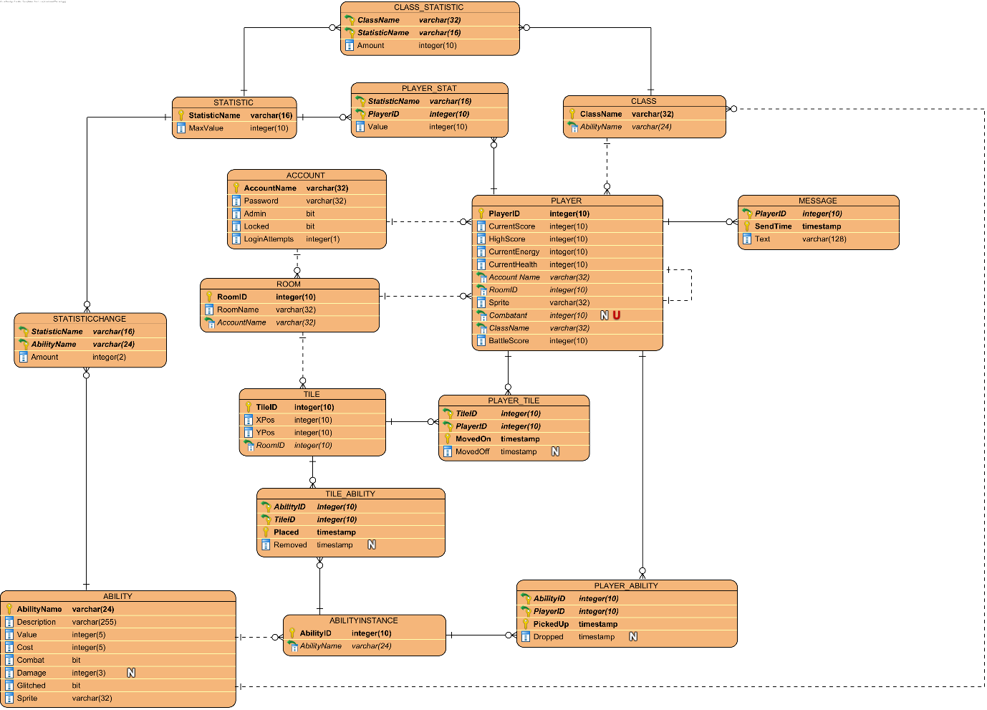

2.2 Changes
- Added a class table which is referenced by the player table and a new class statistic table which stores statistic changes based on class
- The player table now has a self referential connection for combatant
- Battle score (how much score the player has gained from winning combat) is now also tracked as its own column in the player table
- The player tile table and tile ability table now have a removed timestamp as well as a placed timestamp
- Added an ability instance table which allows multiple of the same ability to exist at once

3 Updated CRUD Table
 | Player Login | Incorrect Password | Player Lockout | Player Registration | Laying Out Tiles | Placing Item On Tile | Player Movement | Picking Up Item | Dropping Item | Winning Combat | Losing Combat | Glitch Item Movement | Kill A Room | Change Player Data | Delete An Account | Change Account Data | Player Join Room | Player Send Message | Create Room
Account
AccountName (PK) | _R__ | _R__ | _R__ | CR__ | ____ | ____ | ____ | ____ | ____ | ____ | ____ | ____ | ____ | ____ | ___D | ____ | _R__ | ____ | ____
Password | _R__ | ____ | ____ | C___ | ____ | ____ | ____ | ____ | ____ | ____ | ____ | ____ | ____ | ____ | ___D | _RU_ | ____ | ____ | ____
Admin | _R__ | ____ | ____ | C___ | ____ | ____ | ____ | ____ | ____ | ____ | ____ | ____ | _R__ | ____ | ___D | __U_ | ____ | ____ | ____
Locked | _R__ | ____ | __U_ | C___ | ____ | ____ | ____ | ____ | ____ | ____ | ____ | ____ | ____ | ____ | ___D | __U_ | ____ | ____ | ____
LoginAttempts | __U_ | _RU_ | __U_ | C___ | ____ | ____ | ____ | ____ | ____ | ____ | ____ | ____ | ____ | ____ | ___D | ____ | ____ | ____ | ____
Player
PlayerID (PK) | ____ | ____ | ____ | ____ | ____ | ____ | _R__ | ____ | ____ | _R__ | ____ | ____ | ___D | ____ | ___D | ____ | C___ | _R__ | ____
CurrentScore | ____ | ____ | ____ | ____ | ____ | ____ | ____ | __U_ | __U_ | _RU_ | __U_ | ____ | ___D | __U_ | ___D | ____ | C___ | ____ | ____
HighScore | ____ | ____ | ____ | ____ | ____ | ____ | ____ | __U_ | ____ | __U_ | ____ | ____ | ___D | __U_ | ___D | ____ | C___ | ____ | ____
CurrentEnergy | ____ | ____ | ____ | ____ | ____ | ____ | ____ | ____ | ____ | ____ | ____ | ____ | ___D | __U_ | ___D | ____ | C___ | ____ | ____
CurrentHealth | ____ | ____ | ____ | ____ | ____ | ____ | ____ | ____ | ____ | ____ | ____ | ____ | ___D | __U_ | ___D | ____ | C___ | ____ | ____
AccountName (FK) | ____ | ____ | ____ | ____ | ____ | ____ | ____ | ____ | ____ | ____ | ____ | ____ | ___D | ____ | ___D | ____ | C___ | ____ | ____
RoomID (FK) | ____ | ____ | ____ | ____ | ____ | ____ | ____ | ____ | ____ | ____ | ____ | ____ | ___D | ____ | ___D | ____ | C___ | ____ | ____
Sprite | ____ | ____ | ____ | ____ | ____ | ____ | ____ | ____ | ____ | ____ | ____ | ____ | ___D | ____ | ___D | ____ | C___ | ____ | ____
Combatant (FK) | ____ | ____ | ____ | ____ | ____ | ____ | ____ | ____ | ____ | ____ | ____ | ____ | ___D | ____ | ___D | ____ | C___ | ____ | ____
Class (FK) | ____ | ____ | ____ | ____ | ____ | ____ | ____ | ____ | ____ | ____ | ____ | ____ | ___D | ____ | ___D | ____ | C___ | ____ | ____
BattleScore | ____ | ____ | ____ | ____ | ____ | ____ | ____ | ____ | ____ | __U_ | __U_ | ____ | ___D | ____ | ___D | ____ | C___ | ____ | ____
Message
PlayerID (PK) (FK) | ____ | ____ | ____ | ____ | ____ | ____ | ____ | ____ | ____ | ____ | ____ | ____ | ___D | ____ | ___D | ____ | _R__ | C___ | ____
SendTime (PK) | ____ | ____ | ____ | ____ | ____ | ____ | ____ | ____ | ____ | ____ | ____ | ____ | ___D | ____ | ___D | ____ | _R__ | C___ | ____
Text | ____ | ____ | ____ | ____ | ____ | ____ | ____ | ____ | ____ | ____ | ____ | ____ | ___D | ____ | ___D | ____ | _R__ | C___ | ____
Room
RoomID (PK) | ____ | ____ | ____ | ____ | ____ | ____ | ____ | ____ | ____ | ____ | ____ | ____ | ___D | ____ | ___D | ____ | _R__ | ____ | C___
RoomName | ____ | ____ | ____ | ____ | ____ | ____ | ____ | ____ | ____ | ____ | ____ | ____ | ___D | ____ | ___D | ____ | _R__ | ____ | C___
AccountName (FK) | ____ | ____ | ____ | ____ | ____ | ____ | ____ | ____ | ____ | ____ | ____ | ____ | ___D | ____ | ___D | ____ | _R__ | ____ | C___
Player_Tile
TileID (PK) (FK) | ____ | ____ | ____ | ____ | ____ | ____ | C___ | ____ | ____ | ____ | C___ | _R__ | ___D | ____ | ___D | ____ | _R__ | ____ | ____
PlayerID (PK) (FK) | ____ | ____ | ____ | ____ | ____ | ____ | C___ | ____ | ____ | ____ | C___ | _R__ | ___D | ____ | ___D | ____ | _R__ | ____ | ____
MovedOn (PK) | ____ | ____ | ____ | ____ | ____ | ____ | C___ | ____ | ____ | ____ | C___ | _R__ | ___D | ____ | ___D | ____ | _R__ | ____ | ____
MovedOff | ____ | ____ | ____ | ____ | ____ | ____ | C___ | ____ | ____ | ____ | C___ | _R__ | ___D | ____ | ___D | ____ | _R__ | ____ | ____
Tile
TileID (PK) | ____ | ____ | ____ | ____ | _R__ | _R__ | _R__ | ____ | _R__ | ____ | _R__ | _R__ | ___D | ____ | ___D | ____ | _R__ | ____ | C___
Xpos | ____ | ____ | ____ | ____ | _R__ | ____ | ____ | ____ | ____ | ____ | ____ | ____ | ___D | ____ | ___D | ____ | _R__ | ____ | C___
Ypos | ____ | ____ | ____ | ____ | _R__ | ____ | ____ | ____ | ____ | ____ | ____ | ____ | ___D | ____ | ___D | ____ | _R__ | ____ | C___
RoomId (FK) | ____ | ____ | ____ | ____ | _R__ | ____ | ____ | ____ | ____ | ____ | ____ | ____ | ___D | ____ | ___D | ____ | _R__ | ____ | C__
TILE_ABILITY
Placed (PK) | ____ | ____ | ____ | ____ | ____ | C___ | _R__ | _R__ | C___ | ____ | ____ | CR__ | ___D | ____ | ___D | ____ | _R__ | ____ | ____
TileID (PK) (FK) | ____ | ____ | ____ | ____ | ____ | C___ | _R__ | _R__ | C___ | ____ | ____ | CR__ | ___D | ____ | ___D | ____ | _R__ | ____ | ____
AbilityID (PK) (FK) | ____ | ____ | ____ | ____ | ____ | C___ | _R__ | _R__ | C___ | ____ | ____ | CR__ | ___D | ____ | ___D | ____ | _R__ | ____ | ____
Removed | ____ | ____ | ____ | ____ | ____ | ____ | _R__ | C___ | ____ | ____ | ____ | CR__ | ___D | ____ | ___D | ____ | _R__ | ____ | ____
Ability
AbilityName (PK) | ____ | ____ | ____ | ____ | ____ | CR__ | ____ | _R__ | _R__ | ____ | ____ | ____ | ____ | ____ | ____ | ____ | _R__ | ____ | ____
Description | ____ | ____ | ____ | ____ | ____ | CR__ | ____ | _R__ | _R__ | ____ | ____ | ____ | ____ | ____ | ____ | ____ | _R__ | ____ | ____
Value | ____ | ____ | ____ | ____ | ____ | CR__ | ____ | _R__ | _R__ | ____ | ____ | ____ | ____ | ____ | ____ | ____ | _R__ | ____ | ____
Cost | ____ | ____ | ____ | ____ | ____ | CR__ | ____ | _R__ | _R__ | ____ | ____ | ____ | ____ | ____ | ____ | ____ | _R__ | ____ | ____
Combat | ____ | ____ | ____ | ____ | ____ | CR__ | ____ | _R__ | _R__ | ____ | ____ | ____ | ____ | ____ | ____ | ____ | _R__ | ____ | ____
Damage | ____ | ____ | ____ | ____ | ____ | CR__ | ____ | _R__ | _R__ | ____ | ____ | ____ | ____ | ____ | ____ | ____ | _R__ | ____ | ____
Glitched | ____ | ____ | ____ | ____ | ____ | CR__ | ____ | _R__ | _R__ | ____ | ____ | ____ | ____ | ____ | ____ | ____ | _R__ | ____ | ____
Sprite | ____ | ____ | ____ | ____ | ____ | CR__ | ____ | _R__ | _R__ | ____ | ____ | ____ | ____ | ____ | ____ | ____ | _R__ | ____ | ____
PLAYER_ABILITY
PickedUp (PK) | ____ | ____ | ____ | ____ | ____ | ____ | ____ | C___ | _R__ | ____ | _R__ | ____ | ___D | ____ | ___D | ____ | _R__ | ____ | ____
AbilityID (PK) (FK) | ____ | ____ | ____ | ____ | ____ | ____ | ____ | C___ | _R__ | _R__ | _R__ | ____ | ___D | ____ | ___D | ____ | _R__ | ____ | ____
PlayerID (PK) (FK) | ____ | ____ | ____ | ____ | ____ | ____ | ____ | C___ | _R__ | _R__ | _R__ | ____ | ___D | ____ | ___D | ____ | _R__ | ____ | ____
Dropped | ____ | ____ | ____ | ____ | ____ | ____ | ____ | C___ | __U_ | _R__ | __U_ | ____ | ___D | ____ | ___D | ____ | _R__ | ____ | ____
StatChange
AbilityID (PK) (FK) | ____ | ____ | ____ | ____ | ____ | C___ | ____ | _R__ | ____ | ____ | ____ | ____ | ____ | ____ | ____ | ____ | _R__ | ____ | ____
StatName (PK) (FK) | ____ | ____ | ____ | ____ | ____ | C___ | ____ | _R__ | ____ | ____ | ____ | ____ | ____ | ____ | ____ | ____ | _R__ | ____ | ____
Amount | ____ | ____ | ____ | ____ | ____ | C___ | ____ | _R__ | ____ | ____ | ____ | ____ | ____ | ____ | ____ | ____ | _R__ | ____ | ____
Statistic
StatisticName (PK) | ____ | ____ | ____ | ____ | ____ | C___ | ____ | _R__ | ____ | ____ | ____ | ____ | ____ | ____ | ____ | ____ | _R__ | ____ | ____
MaxValue | ____ | ____ | ____ | ____ | ____ | C___ | ____ | _R__ | ____ | ____ | ____ | ____ | ____ | ____ | ____ | ____ | _R__ | ____ | ____
Player_Statistic
StatisticName (PK) (FK) | ____ | ____ | ____ | ____ | ____ | ____ | _R__ | _R__ | _R__ | ____ | ____ | ____ | ___D | ____ | ___D | ____ | CR__ | ____ | ____
PlayerID (PK) (FK) | ____ | ____ | ____ | ____ | ____ | ____ | _R__ | _R__ | _R__ | ____ | ____ | ____ | ___D | ____ | ___D | ____ | CR__ | ____ | ____
Value | ____ | ____ | ____ | ____ | ____ | ____ | _R__ | __U_ | __U_ | ____ | ____ | ____ | ___D | ____ | ___D | ____ | CR__ | ____ | ____
AbilityInstance
AbilityID (PK) | ____ | ____ | ____ | ____ | ____ | ____ | _R__ | _R__ | _R__ | ____ | ____ | ____ | ___D | ____ | ____ | ____ | _R__ | ____ | C___
AbilityName (FK) | ____ | ____ | ____ | ____ | ____ | ____ | _R__ | _R__ | _R__ | ____ | ____ | ____ | ___D | ____ | ____ | ____ | _R__ | ____ | C___
Class
ClassName (PK) | ____ | ____ | ____ | ____ | ____ | ____ | _R__ | ____ | ____ | ____ | ____ | ____ | ____ | ____ | ____ | ____ | _R__ | ____ | ____
AbilityName (FK) | ____ | ____ | ____ | ____ | ____ | ____ | ____ | ____ | ____ | ____ | ____ | ____ | ____ | ____ | ____ | ____ | _R__ | ____ | ____
Class_Statistic
ClassName (PK) (FK) | ____ | ____ | ____ | ____ | ____ | ____ | _R__ | ____ | ____ | ____ | ____ | ____ | ____ | ____ | ____ | ____ | _R__ | ____ | ____
StatisticName (PK) (FK) | ____ | ____ | ____ | ____ | ____ | ____ | _R__ | ____ | ____ | ____ | ____ | ____ | ____ | ____ | ____ | ____ | _R__ | ____ | ____
Amount | ____ | ____ | ____ | ____ | ____ | ____ | _R__ | ____ | ____ | ____ | ____ | ____ | ____ | ____ | ____ | ____ | _R__ | ____ | ____

4 DAO/GUI Implementation
Player login, including lock out
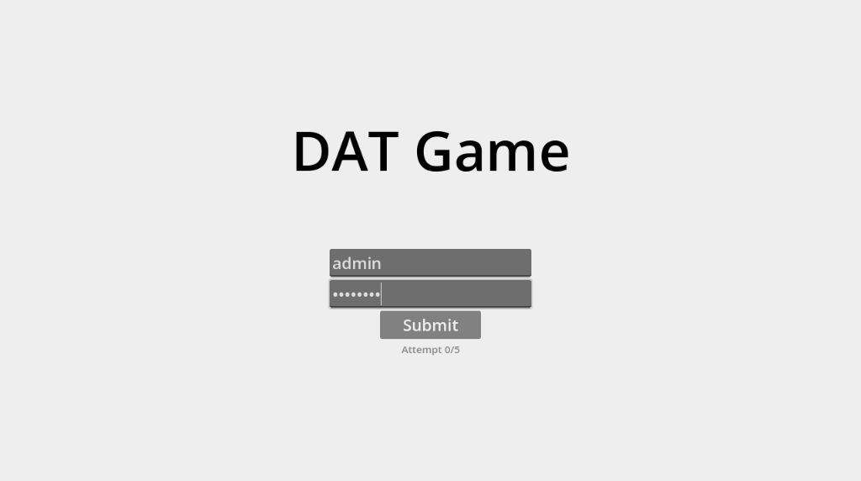 | 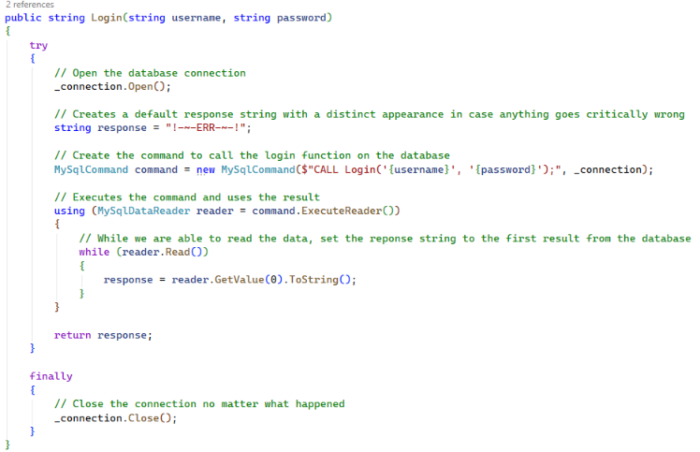
Player registration
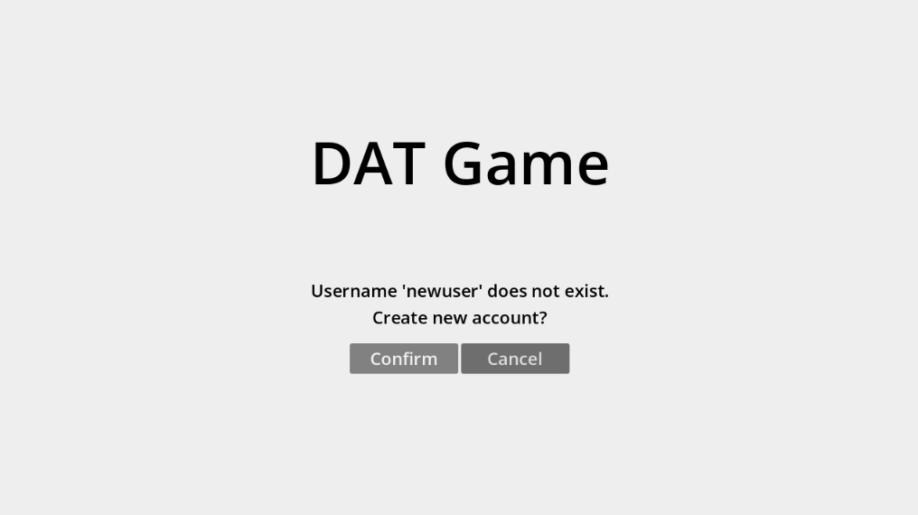 | 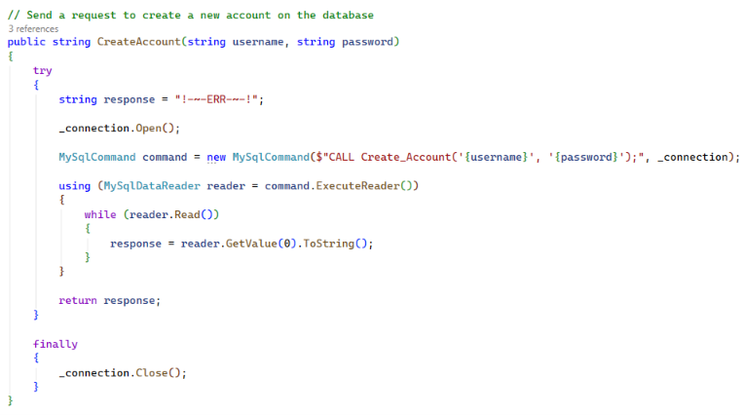
Laying out tiles on a game board
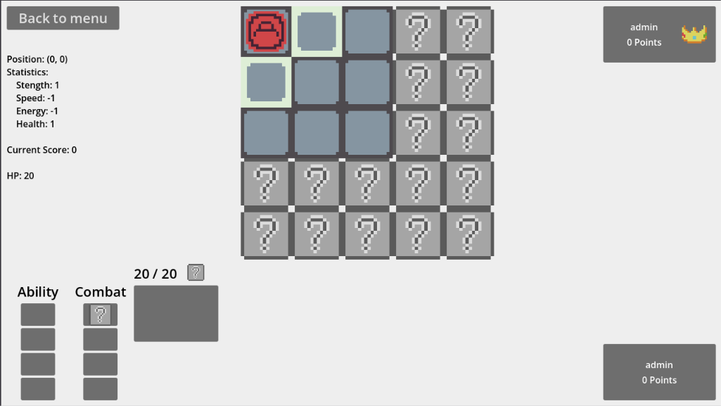 | 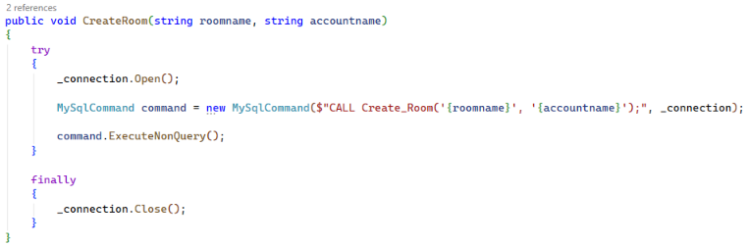
Placing an item on a tile
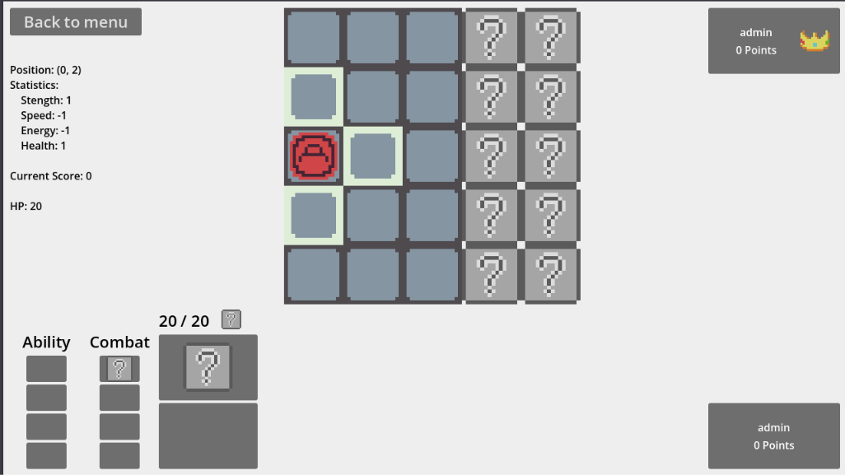
Player game play movement, i.e., moving a player to a “legal” tile
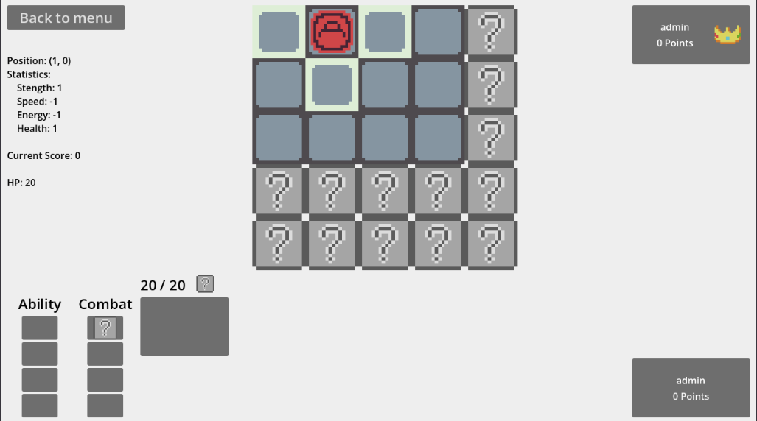 | 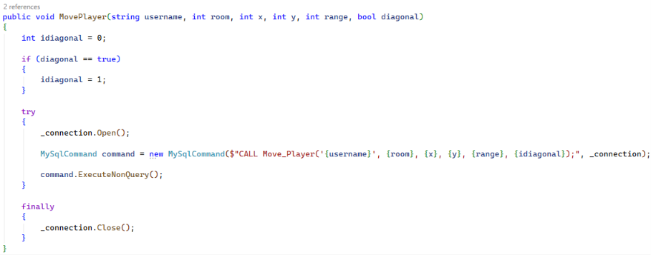
Game play scoring. How do players gain and lose points?
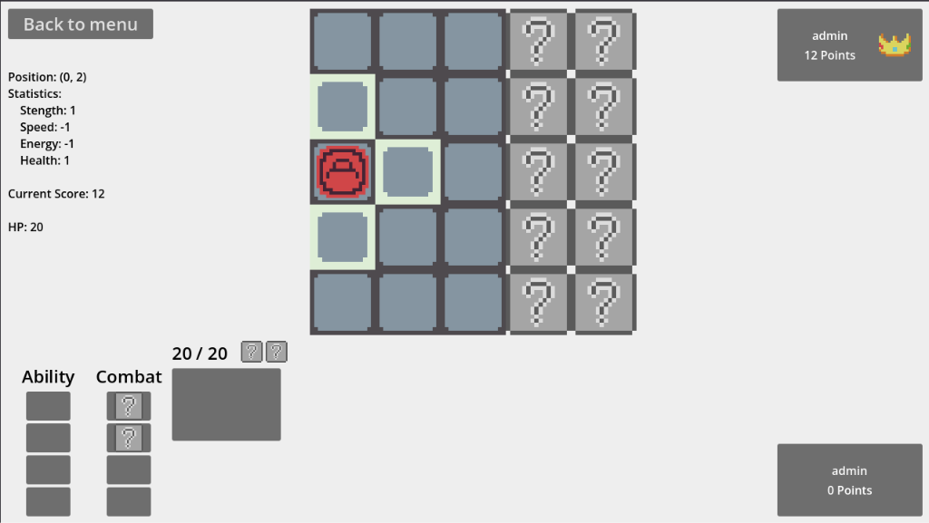 | 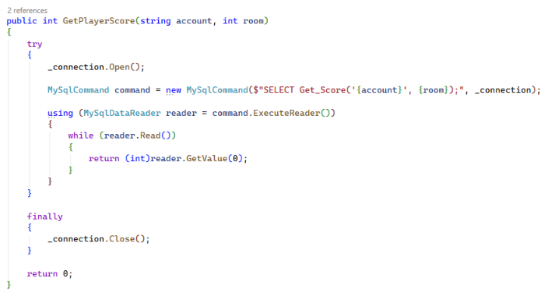
Player game play acquiring inventory, e.g., picking up items off a tile and putting them in an inventory (bag?)
 | 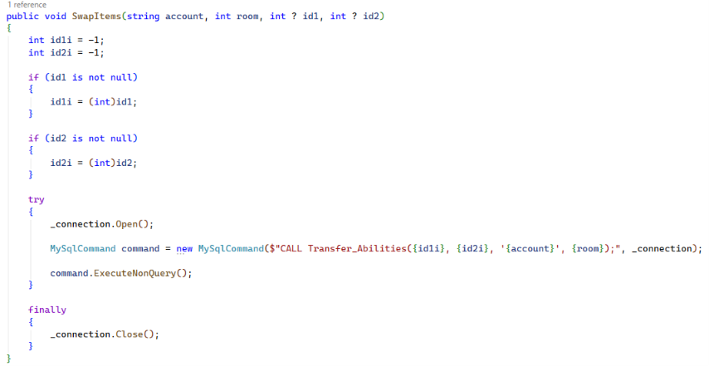
Move an item (NPC effect)
[This is very difficult to show because of the nature of glitch items] | 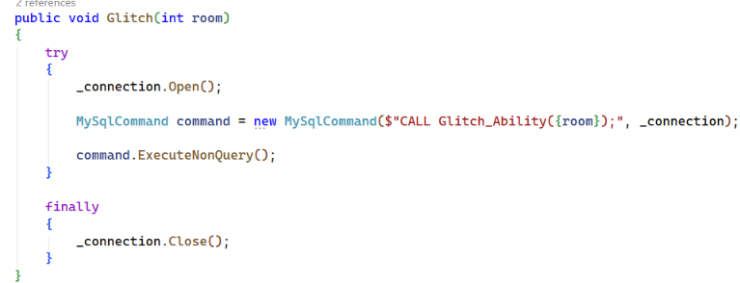
Kill running games
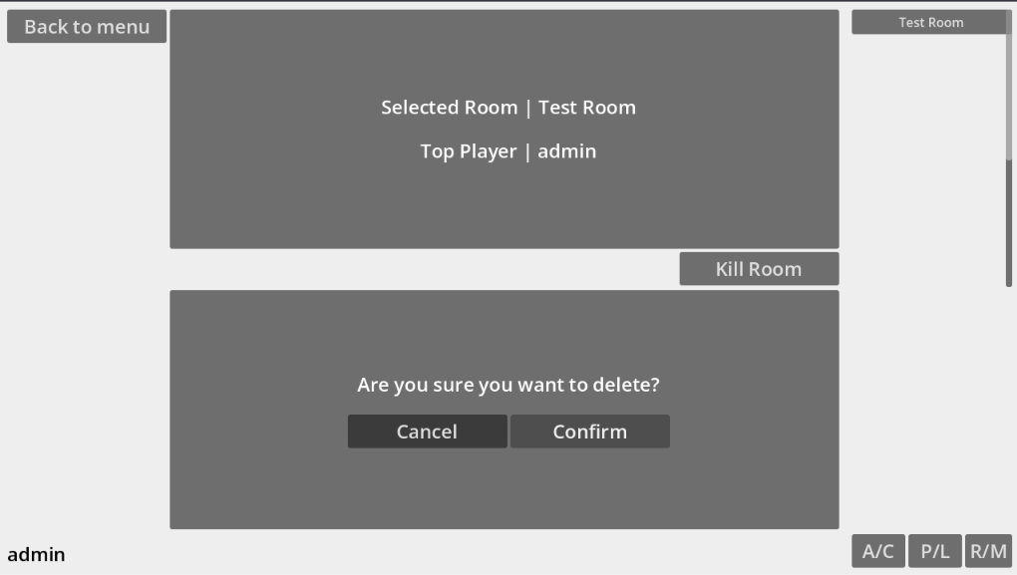 | 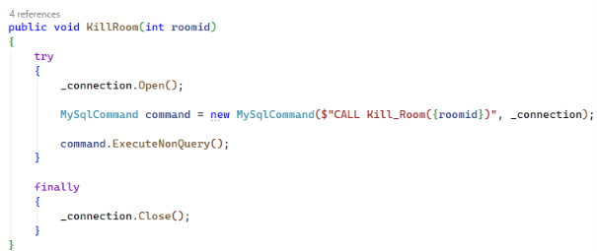
Add new players (Accounts)
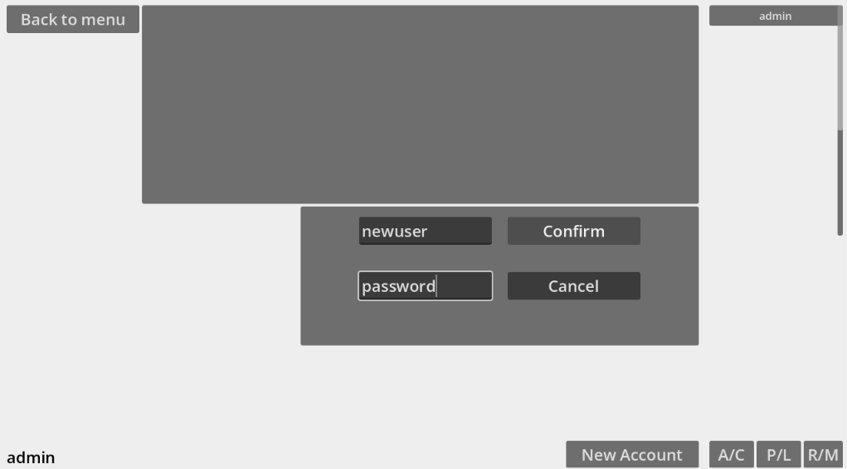
Update data of a player
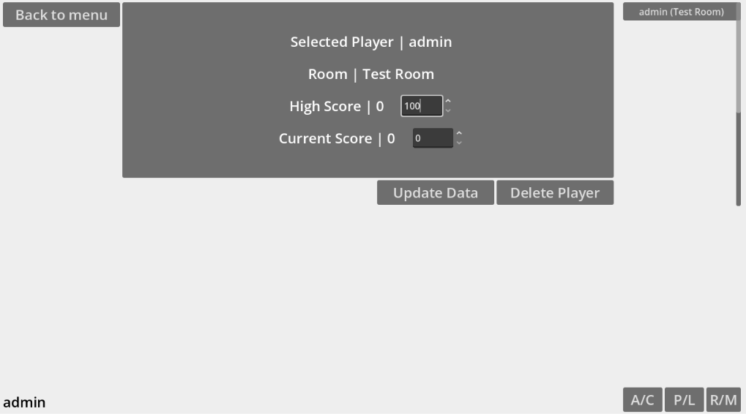 | 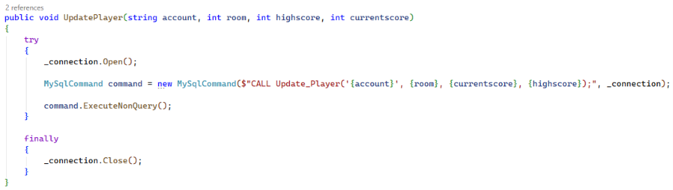
Delete a player
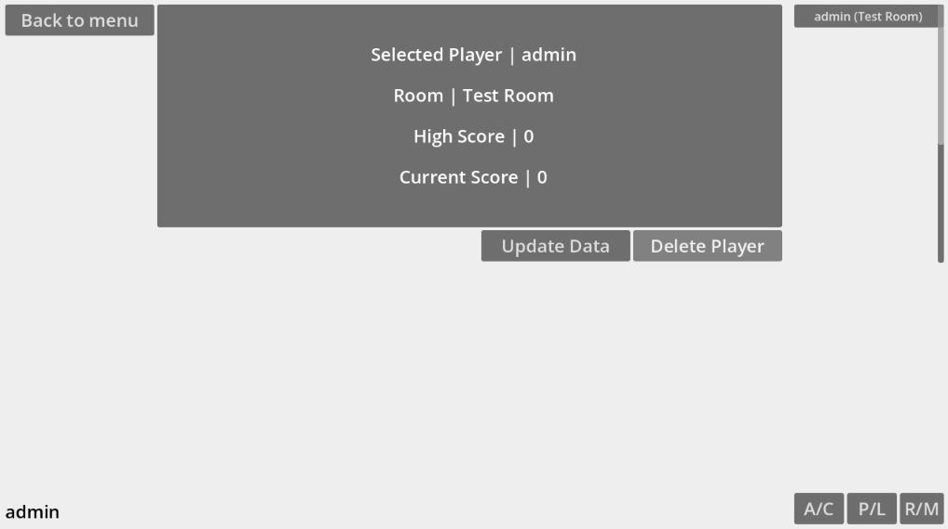 | 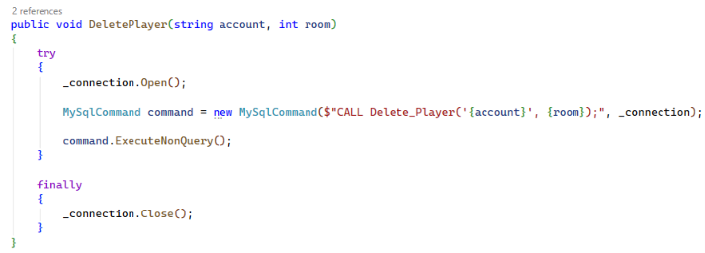

- Milestone 3 -

1 How DAO data is used for error checking
When the DAO calls an SQL procedure, the result will continue as if it were correct. The error handling occurs primarily on the SQL where an exception handler will throw a custom error with a message up to the DAO. The DAO will then catch this error in a try catch and usually display the error in a popup message box on the screen. The exception to this is the login page which displays the errors in an error message under the controls.

1.1 DAO/GUI error handling tests
Login Error: Account not found | Screenshot:
Description: This error is thrown when the user calls the login procedure with a username that isn’t in the database. | Screenshot:
Login Error: Login failed | Screenshot:
Description: Occurs when the user calls the login procedure with a valid username, but the password does not match the corresponding one in the database. | Screenshot:
Login Error: Account locked | Screenshot:
Description: This error is thrown if the user gives a username for the login procedure which has a locked value of 1. | Screenshot:
Create Account Error: Account name already exists | Screenshot:
Description: This error is thrown when the create account procedure is called with a username that has been found in the database. | Screenshot:
Create Room Error: Invalid account name | Screenshot:
Description: This error is thrown if the create room procedure is called with a username that is not in the database. | Screenshot:
Layout Tiles Error: Room does not exist | Screenshot:
Description: This error occurs when the layout tiles procedure calls, but the given room is not in the database. | Screenshot:
Ability Placement Error: Tile does not exist | Screenshot:
Description: This error occurs when the user calls place ability on tile, but the given tile is not in the database. | Screenshot:
Ability Placement Error: Ability does not exist | Screenshot:
Description: Occurs when the place ability on tile procedure is called but the given ability is not in the database. | Screenshot:
Move Player Error: Search radius too small | Screenshot:
Description: This error occurs if the move player procedure is called with a search radius less than 1 | Screenshot:
Move Player Error: Room not found | Screenshot:
Description: | Screenshot:
Move Player Error: Account not found | Screenshot:
Description: | Screenshot:
Move Player Error: Tile already occupied | Screenshot:
Description: | Screenshot:
Move Player Error: Diagonal movement on non-diagonal check | Screenshot:
Description: | Screenshot:
Move Player Error: Tile out of range | Screenshot:
Description: | Screenshot:
Glitch Ability Error: Room does not exist | Screenshot:
Description: | Screenshot:
Item Transfer Error: One or both ability instances not found | Screenshot:
Description: | Screenshot:
Item Transfer Error: Account not found | Screenshot:
Description: | Screenshot:
Item Transfer Error: Room not found | Screenshot:
Description: | Screenshot:
Item Transfer Error: No abilities to swap | Screenshot:
Description: | Screenshot:
Item Transfer Error: Missed all checks | Screenshot:
Description: | Screenshot:
Pickup Error: Invalid player | Screenshot:
Description: | Screenshot:
Pickup Error: Invalid ability instance | Screenshot:
Description: | Screenshot:
Drop Error: Invalid player | Screenshot:
Description: | Screenshot:
Drop Error: Invalid ability instance | Screenshot:
Description: | Screenshot:
Drop Error: Player is not holding that ability | Screenshot:
Description: | Screenshot:
Score Update Error: Invalid player id | Screenshot:
Description: | Screenshot:
Kill Room Error: Room does not exist | Screenshot:
Description: | Screenshot:
Account Update Error: Account does not exist | Screenshot:
Description: | Screenshot:
Account Deletion Error: Account deletion cancelled | Screenshot:
Description: | Screenshot:
Account Deletion Error: Account does not exist | Screenshot:
Description: | Screenshot:
Player Update Error: Player does not exist | Screenshot:
Description: | Screenshot:
Player Deletion Error: Account not found | Screenshot:
Description: | Screenshot:
Player Deletion Error: Room not found | Screenshot:
Description: | Screenshot:

2 Concurrency management in MySQL and .NET C#
Pessimistic Locking
Pessimistic locking is when rows are locked while in use to prevent other users from modifying data in a way that affects the current user (dlevy-msft-sql, n.d.). This is the only form of locking which MySQL supports (Pessimistic vs. Optimistic Locking in MySQL, 2024) in the form of transaction isolation levels which are given to stored procedures. When a user changes data in a table, all other users become unable to interact with that table to prevent data inconsistency.

Optimistic Locking
Optimistic locking does not lock rows and instead the application tries to determine whether another user has changed the row since it was last read each time the data is being modified (dlevy-msft-sql, n.d.). In other words, optimistic locking doesn’t lock but instead tries its best to keep the data up to date as it’s being edited by multiple users. Optimistic concurrency is generally used in environments with a low contention for data (dlevy-msft-sql, n.d.) so any situation where data must absolutely never be wrong, optimistic locking is not a good approach.

MySQL transaction isolation modes
There are 4 transaction isolation modes in MySQL: Read Uncommitted, Read Committed, Repeatable Read and Serializable. Each has increasing levels of protection, usually at the expense of a slower process. Read Uncommitted allows the transaction to read any changes to the database, even if they are later rolled back. Read Committed only allows the transaction to read the values that have been committed by another transaction so rolled back data will never touch the Read Committed transaction. Repeatable Read is similar to Read Committed but also prevents any data from changing between reads. Serializable completely locks the database and prevents anyone else from being able to edit tables while a transaction is acting upon them. This prevents any data changes happening at all but also makes using the database much slower since only one person can modify a specific table at any time.

Direct LINQ connection
LINQ is …

Entity Framework connection
An entity framework is …

